[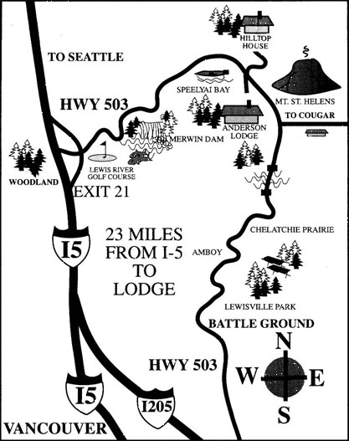](http://andersonlodge.com/andlodge/wp-content/uploads/2014/03/dc4332bfec4492b8422657977fd7ae4d.gif)

EXIT #11